13/12/2023

Chakradhar Bhogapurapu, BIBA

Assessment on SQL, BIBA

Question 1

Querying data by using joins and sub queries.

Ans:

Joins

Joins are used to combine two tables based on a common column between them. There are 4 joins

* Inner Join

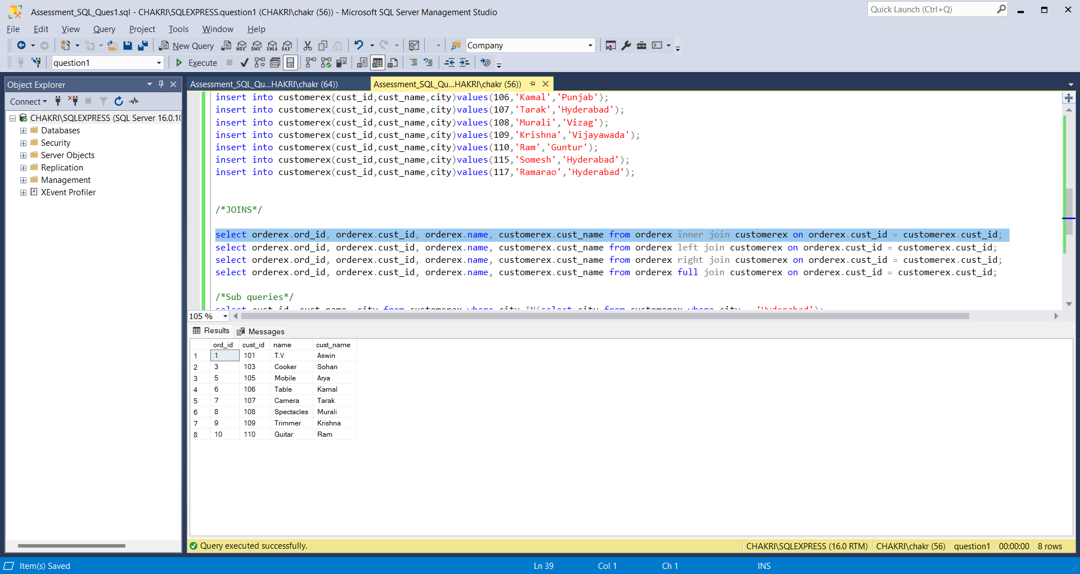

Inner join selects records based on matching values from both the tables.

* Left Join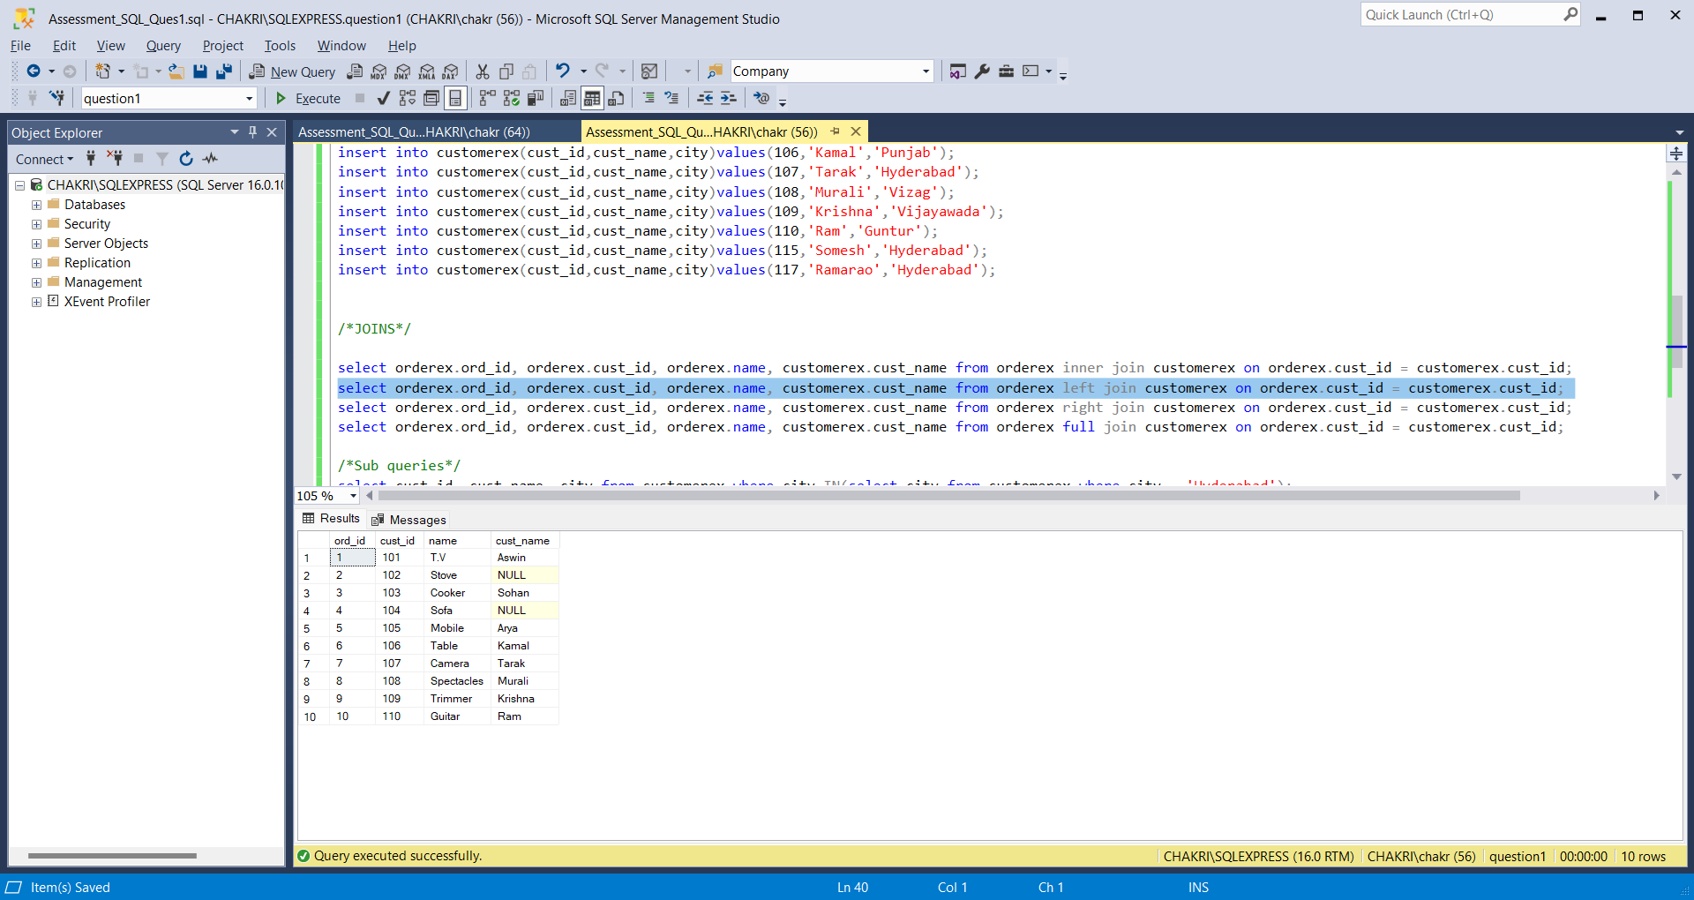

Left join selects values from the left table and the matching values from the right table. The unmatched values from right table is shown as NULL values.

* Right Join

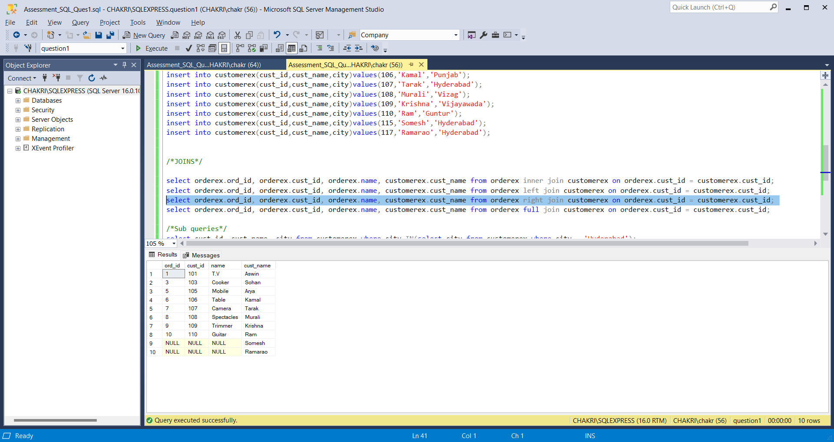

Right join selects values from the right table and the matching values from the left table. The unmatched values from left table is shown as NULL values.

* Full join

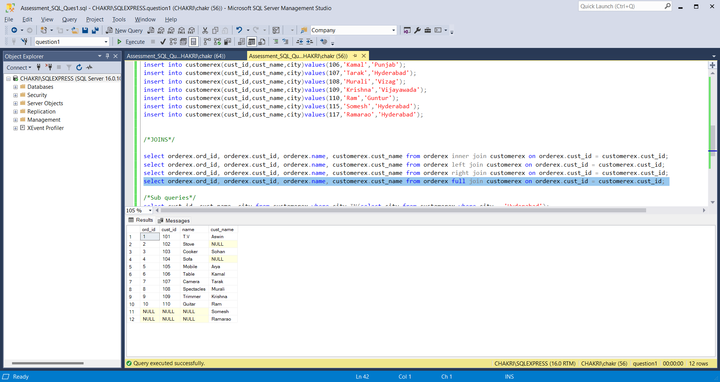

Full join selects values from both the records if the values are matching or not matching. The unmatched values are shown as NULL values from both the tables

SUB QUERIES

The query which is nested inside the other query is known as the sub query. The inner query is the sub query. And the query that consists inner query is known as outer query.

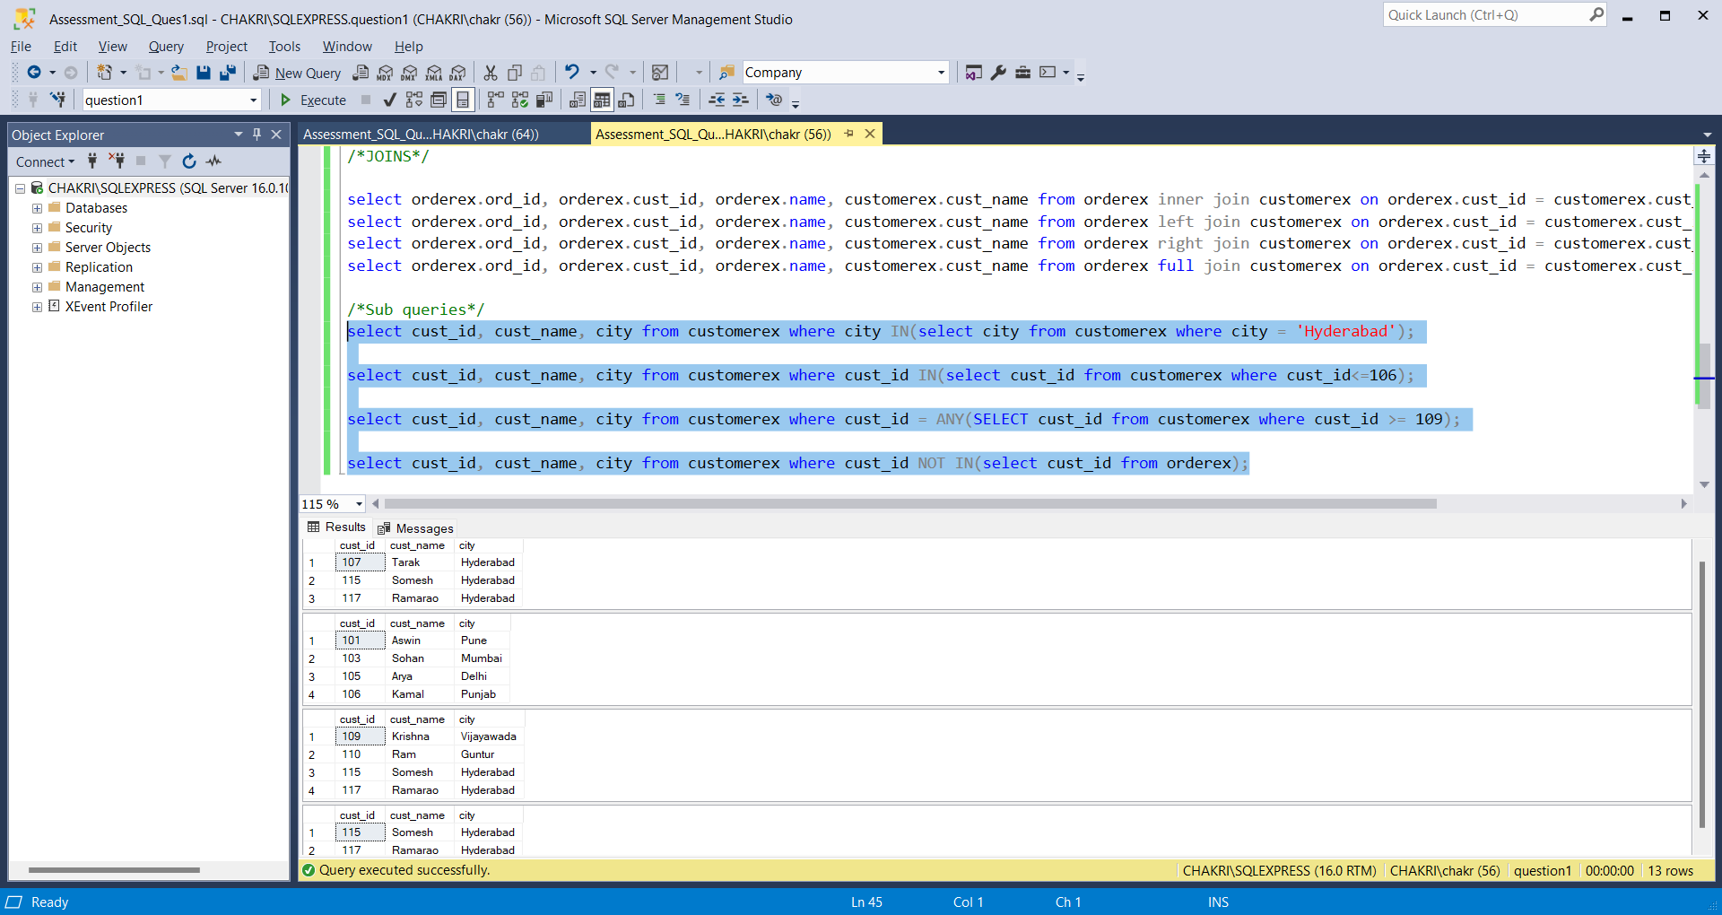

🡪The first command is showing sub query that gives the cust_id, cust_name and city from customerex table whose location is in Hyderabad. The second query gives the city list that has the value as Hyderabad.

🡪The second command gives the cust_id, cust_name and city from customerex table whose cust_id is less than 106.

🡪The third command gives the cust_id, cust_name and city from customerex table whose cust_id>=109

🡪The third command gives the cust_id, cust_name and city from customerex table whose cust_id from the ordered table not in the employee table

Question 2

Manipulating data by using sql commands using group by and having

🡪Group by

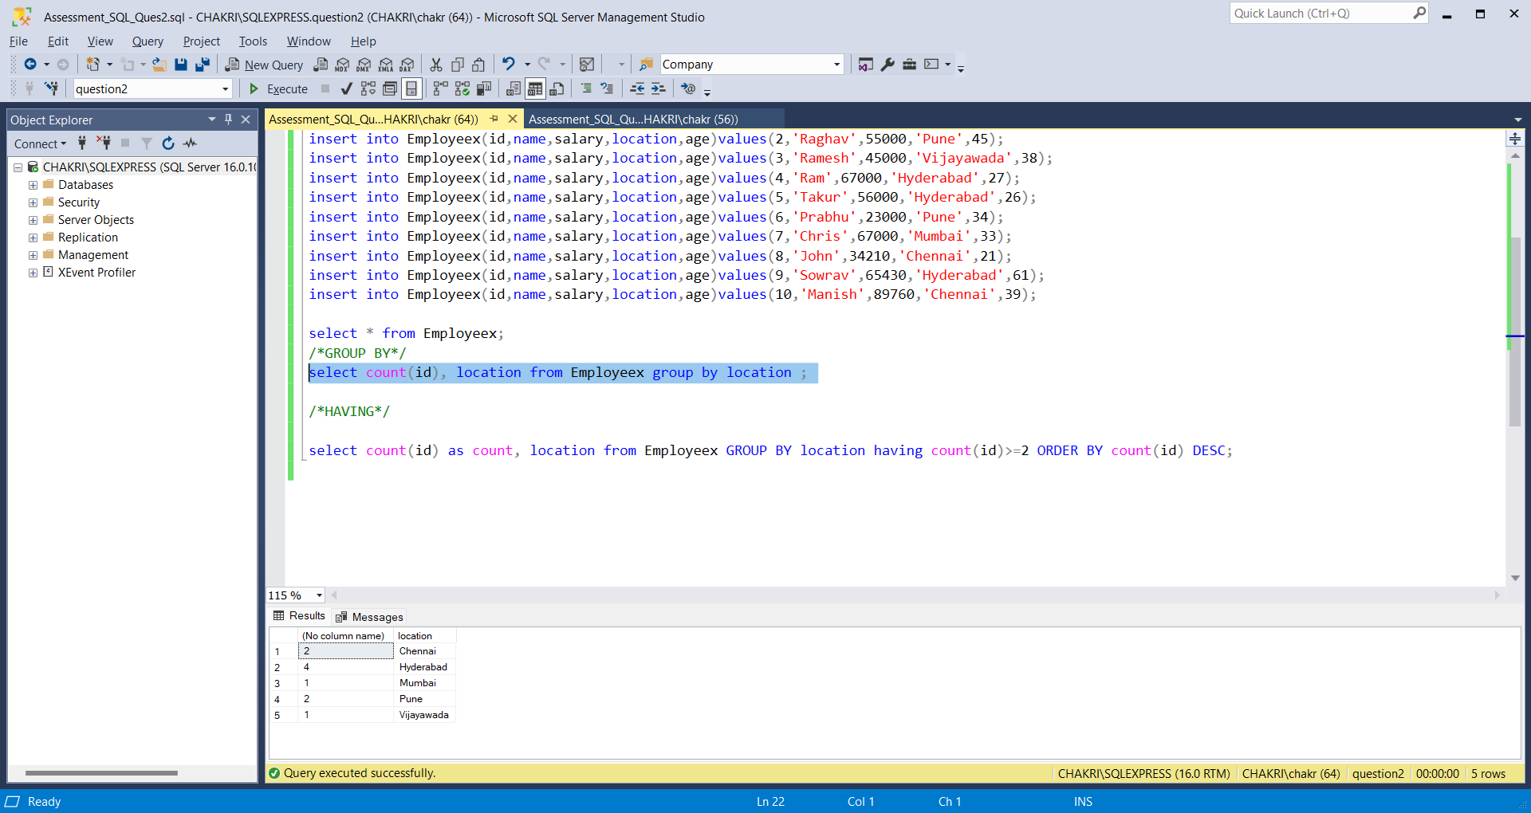

Group by statement is used to group rows based on the column name. Group by statement is used with the aggregate functions like count(), sum(), etc.

In the above query, the id of the employees are counted based on their locations. The id’s are grouped based on locations.

🡪Having

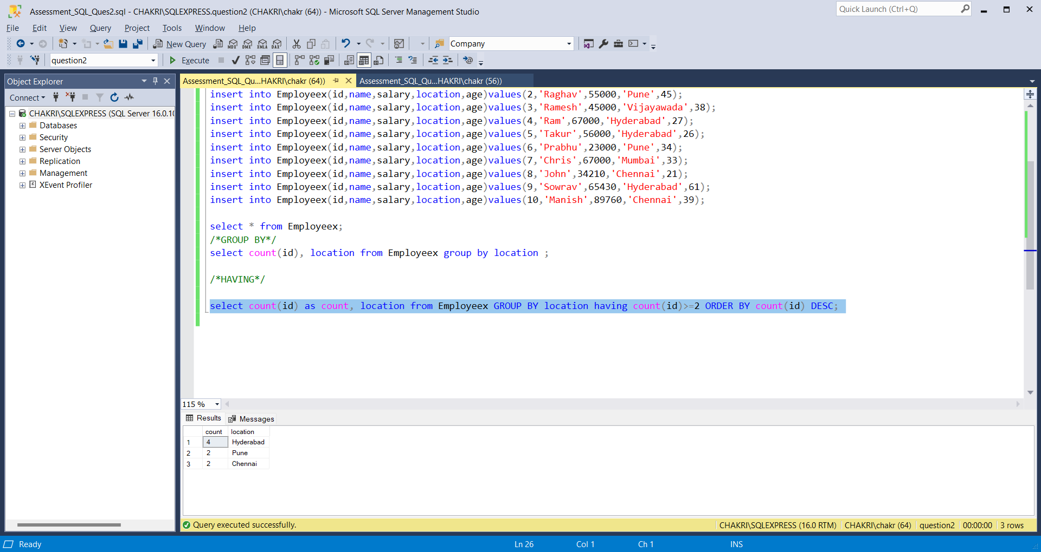

The having clause is used with aggregate function. Having clause is introduced because where clause cannot be used with aggregate functions.

From the above command, having command is used with aggregate function order() to check the condition whose count of id is greater than 2.